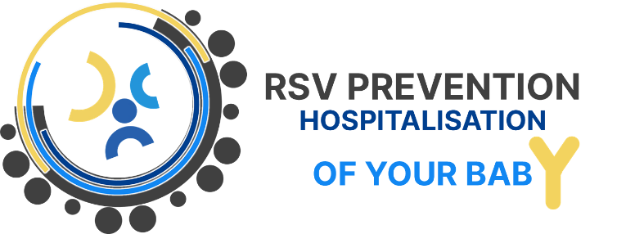


Avoiding a serious RSV infection and hospitalization of your baby.

Dear parent(s),

Bronchiolitis is a frequent infection of the smaller respiratory tract, especially in infants and young children under the age of 2 years, and causes severe respiratory problems, especially in children under 1 year of age. Every year, thousands of children under the age of 6 to 12 months are admitted to Belgian hospitals.
The cause is a virus, usually RSV. RSV is highly contagious and occurs almost exclusively in the autumn and winter months (the so-called 'RSV season') as an epidemic.
There is no causal treatment effective for bronchiolitis (neither aerosols, nor physiotherapy, nor antibiotics, nor expectorant syrups). One can only provide respiratory support (oxygen or more intensive care) and tube feeding or, if necessary, infusion.

It is currently proposed to protect babies born from 16th March 2026 till 30th September 2026 against serious illness and hospitalisation by injection of the drug Nirsevimab (Beyfortus®).

- Is safe
- Is almost fully reimbursed with your doctor's prescription when you have social insurance and will cost you:
  - 12 euros
  - 8 euros for preferential reimbursement
- Name: Nirsevimab (Beyfortus®)
- It is not a vaccine but antibodies and protects your baby for 1 full RSV season
- Reduces the risk of RSV infection AND hospitalization
- Is a one-time injection
- It is recommended to submit the injection from the second week of September 2026.
- Will be administered by your paediatrician or GP
- If you have already received the RSV vaccine Abrysvo® during your pregnancy, you are not entitled to a refund.

- Contact your paediatrician and/or GP as soon as possible (preferably before September 2026). Paediatricians and general practitioners in Belgium work together on this and have access to the same information. Kind&Gezin in Flanders will not administer the product. ONE in Wallonia and Kaleido in East Belgium can also administer.
- Your paediatrician or GP will:
  - provide you with all the information you need;
  - discuss with you the options of where and when the medicine can be administered and what steps you need to take;
- For further questions and more information, it is also best to contact your paediatrician or general practitioner as soon as possible.
- Of course, it is still important to observe a number of measures to avoid infection with RSV or other viruses in your baby.



THE PRODUCT

INTERESTED IN PROTECTING YOUR BABY?




<<Your name/position/service>>

<<Your contact details (phone/email)>>

Foto: iStock
Credit: Narongrit Sritana

